Reporte

Pablo Aguirre Hörmann

12/25/2021

| **Región** | **N° de votantes** | **Tamaño del padrón** | **Participación (%)** |
| --- | --- | --- | --- |
| Arica Y Parinacota | 88.565 | 191.628 | 46,2% |
| Tarapaca | 115.399 | 260.147 | 44,4% |
| Antofagasta | 217.012 | 481.800 | 45% |
| Atacama | 117.744 | 242.779 | 48,5% |
| Coquimbo | 318.356 | 623.580 | 51,1% |
| Valparaiso | 929.212 | 1.612.630 | 57,6% |
| Metropolitana Santiago | 3.459.781 | 5.862.179 | 59% |
| Libertador General Bernardo O'higgins | 443.061 | 780.303 | 56,8% |
| Maule | 495.284 | 892.246 | 55,5% |
| Ñuble | 235.903 | 430.998 | 54,7% |
| Biobio | 736.759 | 1.337.610 | 55,1% |
| La Araucania | 467.654 | 887.606 | 52,7% |
| Los Rios | 190.830 | 353.056 | 54,1% |
| Los Lagos | 387.776 | 746.353 | 52% |
| Aysen General Carlos Ibañez Campo | 46.489 | 98.558 | 47,2% |
| Magallanes Y La Antartica Chilena | 78.936 | 158.483 | 49,8% |

# Relación entre participación y pobreza

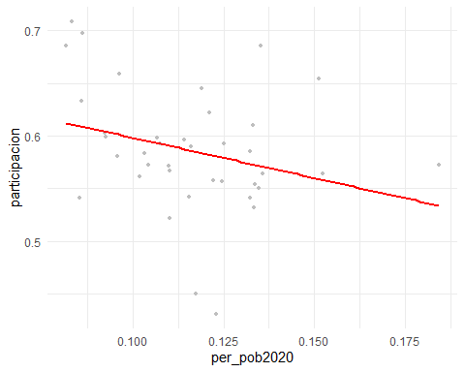

| **com_nom** | **padron** | **vot_tot** | **participacion** |
| --- | --- | --- | --- |
| Algarrobo | 14.805 | 9.760 | 0,6592367 |
| Cabildo | 18.033 | 9.756 | 0,5410082 |
| Calera | 44.870 | 24.861 | 0,5540673 |
| Calle Larga | 11.602 | 6.914 | 0,5959317 |
| Cartagena | 18.730 | 10.722 | 0,5724506 |
| Casablanca | 22.793 | 13.238 | 0,5807923 |
| Catemu | 12.173 | 6.352 | 0,5218106 |
| Concon | 40.829 | 28.002 | 0,6858360 |
| El Quisco | 14.675 | 9.466 | 0,6450426 |
| El Tabo | 12.832 | 8.392 | 0,6539900 |
| Hijuelas | 15.727 | 8.518 | 0,5416163 |
| Isla De Pascua | 6.493 | 2.923 | 0,4501771 |
| Juan Fernandez | 930 | 401 | 0,4311828 |
| La Cruz | 16.779 | 10.627 | 0,6333512 |
| La Ligua | 30.495 | 17.844 | 0,5851451 |
| Limache | 40.056 | 22.915 | 0,5720741 |
| Llaillay | 21.043 | 12.470 | 0,5925961 |
| Los Andes | 55.912 | 32.633 | 0,5836493 |
| Nogales | 19.714 | 10.980 | 0,5569646 |
| Olmue | 16.687 | 9.419 | 0,5644514 |
| Panquehue | 6.644 | 3.972 | 0,5978326 |
| Papudo | 6.309 | 4.325 | 0,6855286 |
| Petorca | 9.415 | 5.102 | 0,5419012 |
| Puchuncavi | 16.733 | 10.211 | 0,6102313 |
| Putaendo | 14.163 | 7.796 | 0,5504484 |
| Quillota | 75.874 | 42.595 | 0,5613913 |
| Quilpue | 135.645 | 81.308 | 0,5994176 |
| Quintero | 25.195 | 14.208 | 0,5639214 |
| Rinconada | 9.605 | 5.977 | 0,6222801 |
| San Antonio | 78.647 | 46.423 | 0,5902704 |
| San Esteban | 15.496 | 9.189 | 0,5929917 |
| San Felipe | 60.113 | 34.070 | 0,5667659 |
| Santa Maria | 12.169 | 6.789 | 0,5578930 |
| Santo Domingo | 11.869 | 8.409 | 0,7084843 |
| Valparaiso | 287.931 | 153.082 | 0,5316621 |
| Villa Alemana | 100.481 | 60.590 | 0,6029996 |
| Vina Del Mar | 302.008 | 172.591 | 0,5714782 |
| Zapallar | 9.155 | 6.382 | 0,6971054 |